39.34: Eq. (39.18): 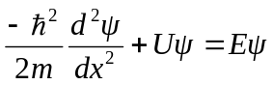
Let 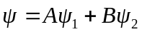 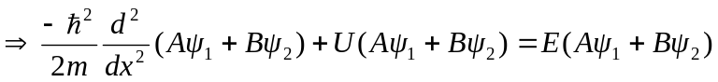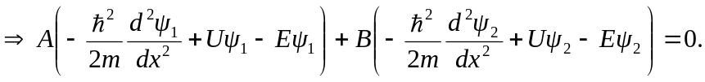
But each of 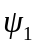 and 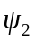 satisfy Schröedinger’s equation separately so the equation still holds true, for any A or B.

